News Release | U.S. Coast Guard 8th District Public Affairs Detachment Texas  Contact: 8th District Public Affairs Detachment Texas  Office: 281-464-4810  After Hours: 832-293-1293  PA Detachment Texas online newsroom
Coast Guard responds to aground tug boat near Corpus Christi, Texas
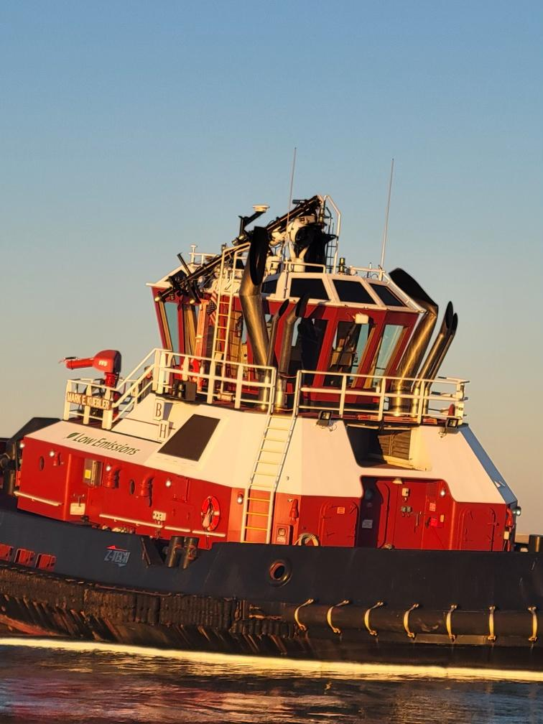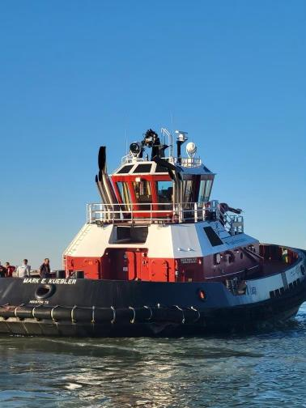
Editors' Note: Click on images to download high-resolution version.
CORPUS CHRISTI, Texas — The Coast Guard is responding to a tug boat that ran aground near the South Texas Gateway refinery in Corpus Christi, Monday.
Coast Guard Sector Corpus Christi command center watchstanders received a call at 4 p.m. Sunday, from the agent of G&H Towing stating that the tug Mark E. Keubler had ran aground outside the channel near the South Texas Gateway refinery and was taking on water.
Watchstanders issued a safety marine information broadcast and directed the launch of a Coast Guard Station Port Aransas 45-foot Response Boat–Medium crew to assist with de-watering.
Once on scene, the RB–M crew began assisting with de-watering efforts.
Before running aground there was reportedly a collision between the tug boat Mark E. Keubler and the bulk carrier Nisalah. Responders did not observe any signs of pollution and there were no reported injuries.
The Coast Guard currently has pollution responders on scene monitoring salvage operations.
For more information follow us on Facebook and Twitter.
-USCG-

Questions for the Coast Guard?
Contact Us
For more Coast Guard news, visit our online newsroom here.
STAY CONNECTED:
SUBSCRIBER SERVICES:
Manage Preferences | Unsubscribe | Help

Privacy Policy | GovDelivery is providing this information on behalf of U.S. Department of Homeland Security, and may not use the information for any other purposes.
This email was sent to operations@rssaonline.com

This email was sent to operations@rssaonline.com using GovDelivery Communications Cloud on behalf of: U.S. Coast Guard · U.S. Department of Homeland Security · Washington, DC 20528 · 800-439-1420

