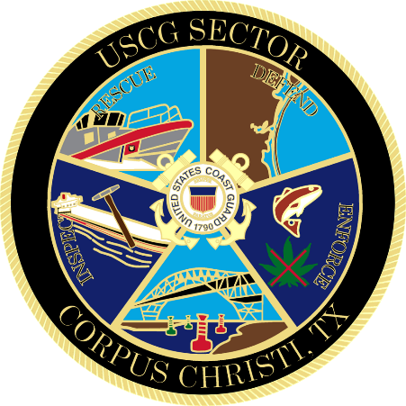

Marine Safety Information Bulletin

44-24

Worksite – CCSC, Inner Harbor

Issue Date: June 24, 2024

The Captain of the Port is establishing a worksite in the Corpus Christi Ship Channel, Inner Harbor. Callan Marine has informed the U.S. Coast Guard that they will be performing dredge operations in the inner harbor, on June 24^{th,} 2024, through July 30th, 2024, from 10 p.m. to 6 a.m. each night. This operation may impact navigation and may require vessels to take appropriate action for the protection of personnel, vessels, and the marine environment. The coordinates of the work area are 27°49’49.95”N, 97°29’44.25”W; 27°49’47.53"N, 97°29.46.29"W; 27°49'43.79"N, 97°29'42.16"W; 27°49’39.12"N, 97°29’46.18”W; 27°49’33.09"N, 97°29’37.38"W; 27°49’30.22"N, 97°29’20.30"W; 27°49’27.17"N, 97°29’15.91”W; 27°49’29.50"N, 97°29’13.79"W; 27°49’41.51"N, 97°29’26.47"W; 27°49’46.42"W, 97°29'33.57"W. No vessels should transit through the work area without coordinating through the U.S. Coast Guard. The M/V BRANDON JOHN and DREDGE GENERAL ARNOLD will be monitoring VHF channel 12 and 71.

Concerned parties with urgent concerns can contact the U.S. Coast Guard Sector Corpus Christi Command Center at 1-800-874-2143; or for non-urgent questions and concerns, email CCWaterways@uscg.mil.

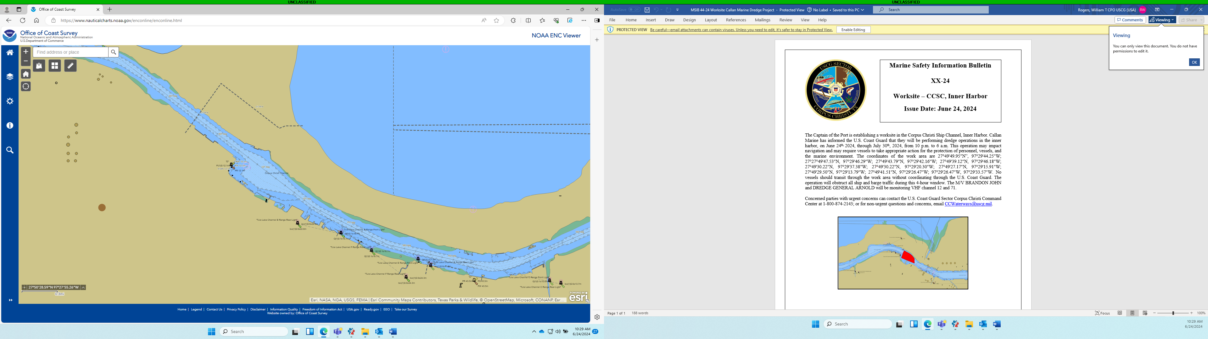

D. C. BARATA
Rear Admiral, U.S. Coast Guard
Commander, District Eight

